**Homework 2. Solutions**

Teacher: Paul Briard

**Ex. 1.** A man is dragging a trunk up the loading ramp of a mover’s truck. The ramp as a slope angle of $20.0°$ and the man pulls up upward with a force $\vec{F}$ whose direction makes an angle of $30.0°$ with the ramp. (a) if the component $F_{x}$ parallel to ramp is 60.0 N, how large is the magnitude of the force $\vec{F}$ (unit: N). (b) How large will be the component $F_{y}$ perpendicular to the ramp (unit: N)?

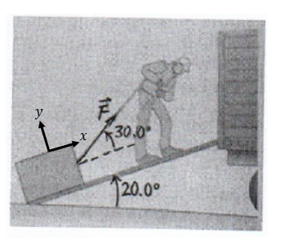

**Solution:**

(a)

$$F_{x}=F\cos{30°}$$

$$F=\frac{F_{x}}{\cos{30°} }=\frac{60.0}{\sqrt{3}/2}=69.3 N$$

(b)

$$F_{y}=F\sin{30°}=20\sqrt{3}=34.6 N$$

**Ex. 2.** A solid uniform of mass $m=$ 45.0-kg ball of diameter 32.0 cm is supported against a vertical **frictionless** wall using a thin 30.0-cm wire of negligible mass, as shown on the figure. (a) Draw the free body diagram of the ball, the forces (tension force exerted by the rope $\vec{T}$, normal force exerted by the wall $\vec{n}$, weight $\vec{w}$) are applied at the center of mass of the ball (b) Describe the tension $T$ in the wire (i.e. the magnitude of the tension force) in respect with $m,g, α$ (angle $α$ is shown on the figure, $g=9.81 m.s^{−2}$) and then calculate the tension in the wire. (c) How hard does the ball push against the wall ? (i.e. calculate the magnitude of the normal force exerted by the ball on the wall).

Help: The Newton’s first law has to be used.

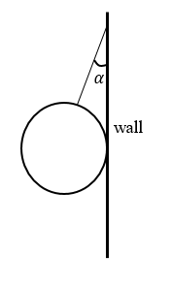

**Solution:**

(a)

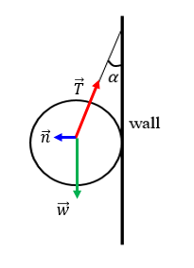

Take care that the ball is at rest so, the net force must be equals $\vec{0}$, i.e. $\vec{w}+\vec{T}+\vec{n}=\vec{0}$.

This must be respected on the free body diagram.

(b)

Along the vertical direction, using Newton’s first principle:

$$T\cos{α}=mg$$

To calculate $\cos{α}$ we can do:

$$\sin{α}=\frac{16}{30+16}=\frac{16}{46}=0.347$$

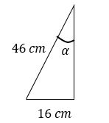

Then, $\cos{α}=0.937$

The tension is:

$$T=\frac{mg}{\cos{α}}=\frac{\left(45.0 kg\right)\left(9.81 m.s^{−2}\right)}{0.937}=471 N$$

c) By applying the Newton’s third law, the normal force exerted by the ball on the wall and the normal force exerted by wall on the ball have same magnitude and opposite directions.

The magnitude of the normal force is (obtain using the Newton’s first law on the ball):

$$n=T\sin{α}=471×0.347=163 N$$

**Ex. 3.** A block with mass $m_{1}$ is placed on an inclined plane with slope $α$ and is connected to a second hanging block with mass $m_{2}$ by a cord passing over a small frictionless pulley. The coefficient of static friction is $μ_{S}$ and the coefficient of kinetic friction is $μ_{k}$ (friction of the block of mass $m_{1}$ on the table). The magnitude of the tension force $T$ exerted on both blocks is the same (a) Draw the free body diagram on mass $m_{1}$ and $m_{2}$ (forces applied to the center of mass) for block $m_{1}$ moves up the plane at constant speed once it is set in motion (b) Describe the mass $m_{2}$ for which block $m_{1}$ moves up the plane at constant speed once it is set in motion (in respect to $m_{1},α,μ_{k}$). c) Describe the mass $m_{2}$ for which block $m_{1}$ moves down the plane at constant speed once it is set in motion (in respect to $m_{1},α,μ_{k}$). (d) For what range of $m_{2}$ will the blocks remains at rest if they are released from rest (in respect with $m_{1},α,μ_{S}$)

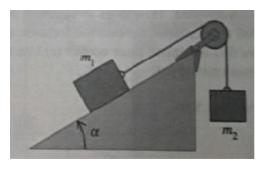

Solution:

(a)

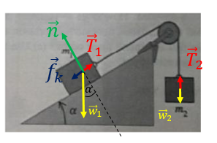

Take care that for a linear motion at constant velocity, the net force on a body is zero, which must be respected in the free body diagram. The block $m_{1}$ moves up and the friction force must be represented opposed to the motion.

(b) The magnitude of the friction force exerted to the first block is: $f_{k}=μ_{k}n$ and using the Newton’s first law on the first block we obtain $n=m_{1}g\cos{α}$, thus $f_{k}=μ_{k}m_{1}g\cos{α}$. We obtain also an expression of the magnitude of the tension force (the same magnitude of tension force $T$ for both blocks):

$$T=\left|{\vec{T}}_{1}\right|=m_{1}g\sin{α}+μ_{k}m_{1}g\cos{α}$$

Using the Newton’s first law on the second block, we obtain:

$$m_{2}g=m_{1}g\sin{α}+μ_{k}m_{1}g\cos{α}$$

Thus, the block must have its mass such as:

$$m_{2}=m_{1}\sin{α}+μ_{k}m_{1}\cos{α}$$

(c) Using the same way that previously but with a first block moving down the plane, we obtain:

$$m_{2}=m_{1}\sin{α}−μ_{k}m_{1}\cos{α}$$

(d) Take care that if the block 1 is at rest, then the magnitude of the friction force exerted on it is $f_{S}=μ_{S}n$. Excepted for coefficient of friction, the same way used to solve the questions (b) and (c) can be used.

At the up limit: $$m_{2}g=m_{1}g\sin{α}+μ_{S}m_{1}g\cos{α}$$

At the down limit:

$$m_{2}g=m_{1}g\sin{α}−μ_{S}m_{1}g\cos{α}$$

The range of mass of block 2 at which the blocks stay at rest is then:

$$\left[m_{1}\sin{α}−{μ_{S}m}_{1}g\cos{α},m_{1}\sin{α}+{μ_{S}m}_{1}g\cos{α} \right]$$

**Ex. 4** A block with mass m slides with initial velocity 𝑣0 on a horizontal surface along the $+x−$ direction. A retarding force ${\vec{F}}_{R}$ that the surface exerts on the rock is proportional to the square root of the instantaneous velocity of the block (its x-component is $F_{R,x}=−kv^{1/2}$). (a) Describe the acceleration vector of the block $\vec{a}$ (magnitude in respect with $m,k,v$ and direction) (b) Find expressions for the velocity $v_{x}(t)$ and position $x(t)$ of the block as a function of time (in respect to time $t, m,k,v_{0},x_{0}$), where $v_{0}$ is the initial velocity (i.e. at time $t=t_{0}=0$ s) and $x_{0}$ is the initial position of the block (c) In terms of m, k, and𝑣0, at what time will the rock come to rest? (d) In terms of m, k, and 𝑣0, what is the distance of the block from its starting point when it comes to rest?

**Solution:**

(a)

On a horizontal surface the weight and the normal force are opposed and have the same magnitude, thus the net force corresponds to the retarding force. The acceleration vector is opposed to the motion and its magnitude is, using the Newton’s 2nd law:

$$a=\frac{kv^{1/2}}{m}$$

Take care that the magnitude of a vector is always positive. If you write:

$$a=−\frac{kv^{1/2}}{m}$$

This means that the $a$ in this equation is a component of the acceleration vector. So, to avoid misunderstanding it is better to keep “ $a$” as the magnitude of the acceleration vector: $a=\left|\vec{a}\right|$ and to use symbol $a_{x}$ for the x-component, for a motion along the x-axis.

(b)

Considering a motion toward the +x-direction, the $x$-component of the acceleration is:

$$a_{x}=−\frac{kv^{1/2}}{m}$$

$$\frac{dv_{x}}{dt}=−\frac{kv^{1/2}}{m}$$

$$\frac{dv_{x}}{{v_{x}}^{1/2}}=−\frac{k}{m}dt$$

$$\int_{v_{0}}^{v_{x}}{\frac{dv_{x}}{{v_{x}}^{1/2}}}=\int_{t_{0}=0}^{t}{−\frac{k}{m}dt}$$

$${\left[2{v_{x}}^{1/2}\right]}_{v_{0}}^{v_{x}}=−\frac{k}{m}t$$

$$2{v_{x}}^{1/2}−2{v_{0}}^{1/2}=−\frac{k}{m}t$$

$${v_{x}}^{1/2}={v_{0}}^{1/2}−\frac{k}{2m}t$$

$$v_{x}(t)={\left({v_{0}}^{1/2}−\frac{k}{2m}t\right)}^{2}=v_{0}−\frac{k{v_{0}}^{1/2}}{m}t+\frac{k^{2}}{4m^{2}}t^{2}$$

To find $x(t)$ we use, $v_{x}(t)=dx/dt$

$$\frac{dx}{dt}=v_{0}−\frac{kv_{0}}{m}t+\frac{k^{2}}{4m^{2}}t^{2}$$

$$dx=\left(v_{0}−\frac{kv_{0}}{m}t+\frac{k^{2}}{4m^{2}}t^{2}\right)dt$$

$$\int_{x_{0}}^{x}{dx}=\int_{t_{0}=0}^{t}{\left(v_{0}−\frac{kv_{0}}{m}t+\frac{k^{2}}{4m^{2}}t^{2}\right)dt}$$

$$x−x_{0}=\int_{t_{0}=0}^{t}{v_{0}dt}+\int_{t_{0}=0}^{t}{−\frac{kv_{0}}{m}t dt}+\int_{t_{0}=0}^{t}{\frac{k^{2}}{4m^{2}}t^{2}dt}$$

$$x−x_{0}={\left[v_{0}t\right]}_{t_{0}=0}^{t}+{\left[−\frac{kv_{0}}{2m}t^{2}\right]}_{t_{0}=0}^{t}+{\left[\frac{k^{2}}{12m^{2}}t^{3}\right]}_{t_{0}=0}^{t}$$

$$x(t)=x_{0}+v_{0}t−\frac{k{v_{0}}^{1/2}}{2m}t^{2}+\frac{k^{2}}{12m^{2}}t^{3}$$

(of course, most of these steps can be skipped, I just give them to be sure everything if clear for you)

(c)

$$v_{x}\left(t\right)=v_{0}−\frac{k{v_{0}}^{\frac{1}{2}}}{m}t+\frac{k^{2}}{4m^{2}}t^{2}=0$$

We obtain:

$$t=\frac{2m{v_{0}}^{1/2}}{k}$$

(d)

$$x(t=\frac{2m{v_{0}}^{1/2}}{k})=x_{0}+\frac{2m{v_{0}}^{3/2}}{k}−\frac{2m{v_{0}}^{3/2}}{k}+\frac{k^{2}}{12m^{2}}{\left(\frac{2m{v_{0}}^{1/2}}{k}\right)}^{3}$$

$$x(t=\frac{2m{v_{0}}^{1/2}}{k})=x_{0}+\frac{2mv_{0}^{3/2}}{3k}$$